Q1. Construct the 3D model with the help of the orthographic views given above.
(The values of A = 81.00 B = 57.00 C = 43.00 are as follows)
(Dimensions are in mm.)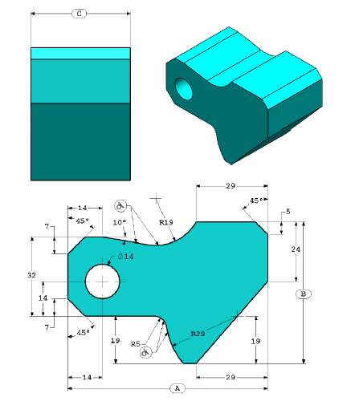

Q2. Construct the 3D model with the help of the orthographic views given above.
(Dimensions are in mm.)
(Ignore the mass in the question)
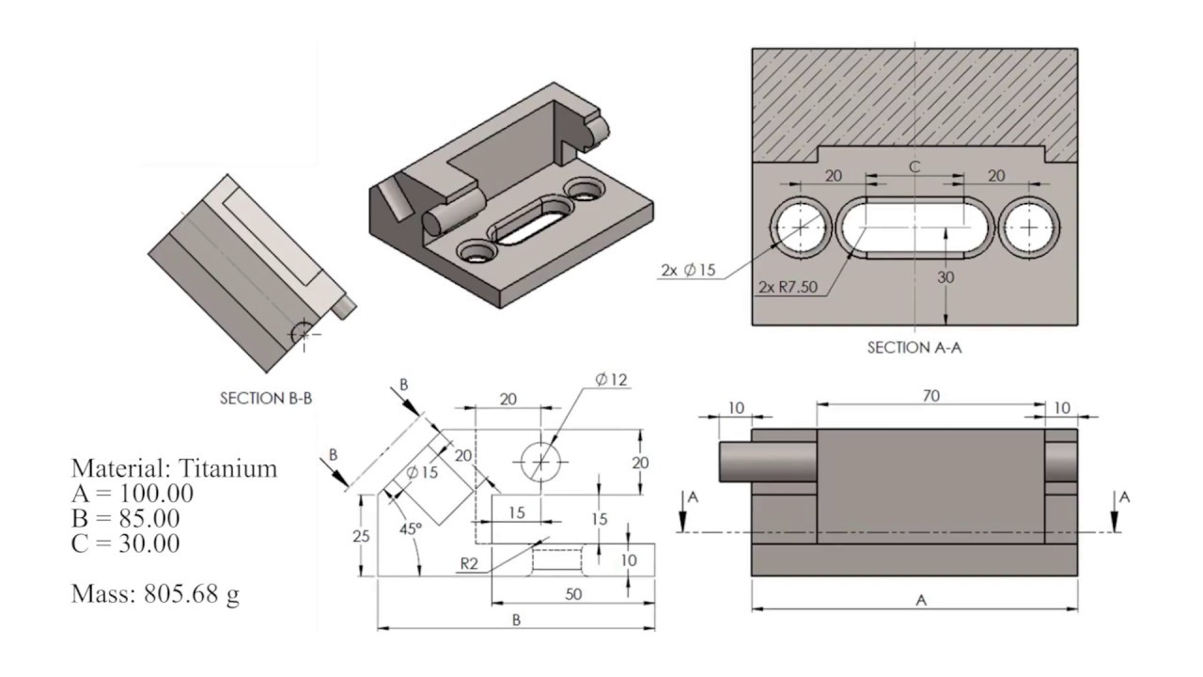

Q3. Model a Fuselage based on xflr you designed for assignment 3 last week.
1.The fuselage should be made of choroplast which is a sheet of 3mm.
2.Think of how wing, tail and propulsion system will be mounted of the fuselage and include that in the design with respect to the xflr.
4.The motor mount should be of 5mm thickness. And it should be a square of 7mmx7mm. Made out of ply.

